TOAL ACTIVE POWER [MW] WeatherType Present

0 0.032078 Weather_Broken clouds 0

1 0.032078 Weather_Broken clouds 0

2 0.032078 Weather_Broken clouds 0

3 0.032078 Weather_Broken clouds 0

4 0.032078 Weather_Broken clouds 0

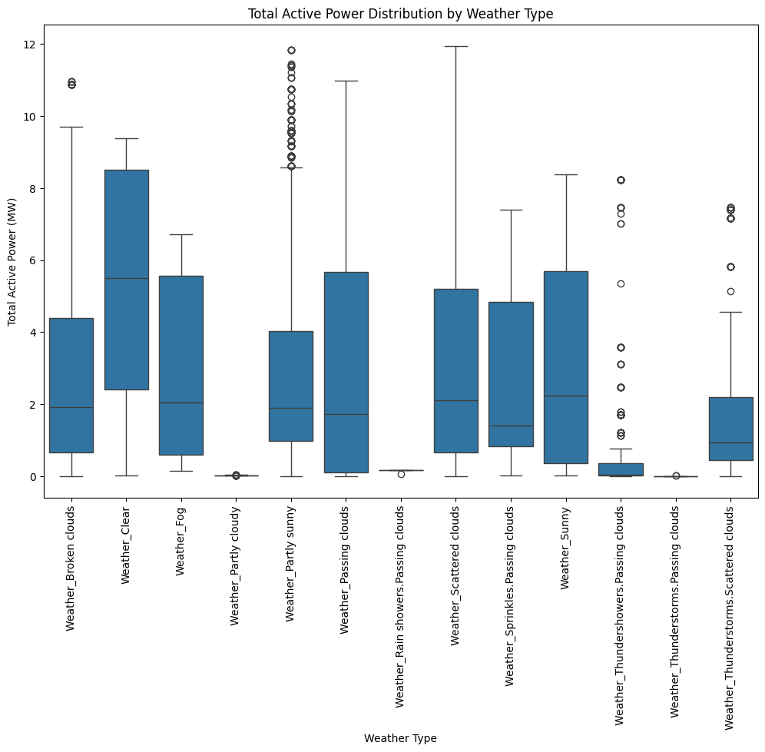

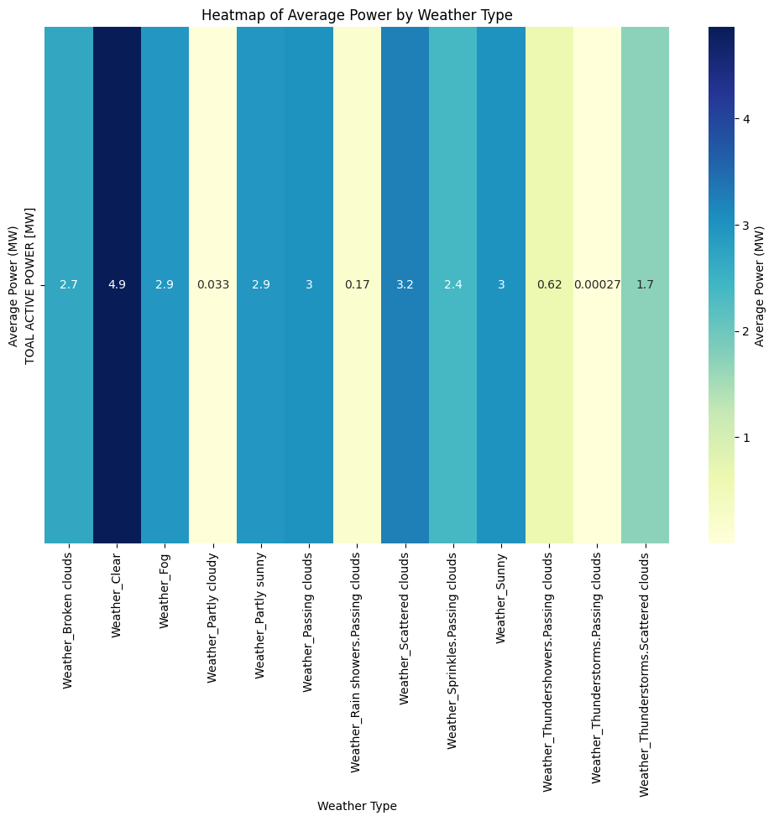

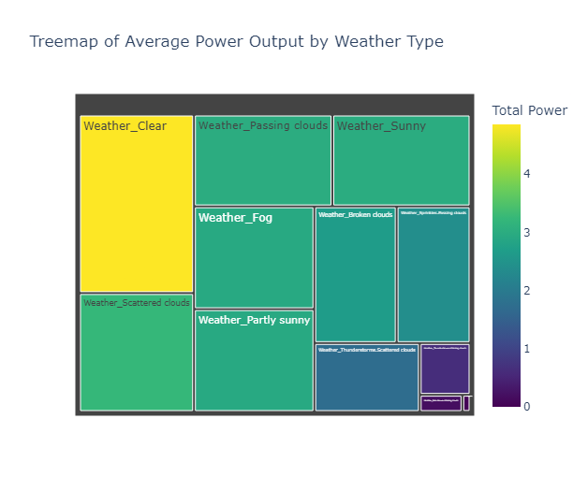

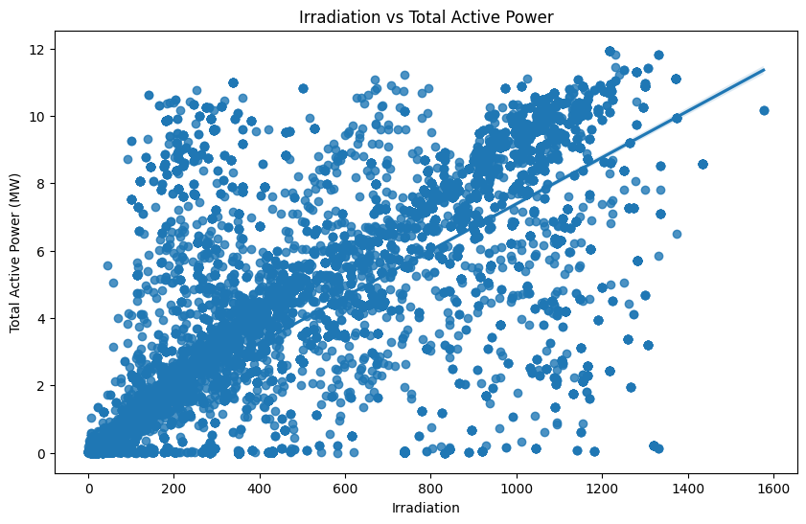

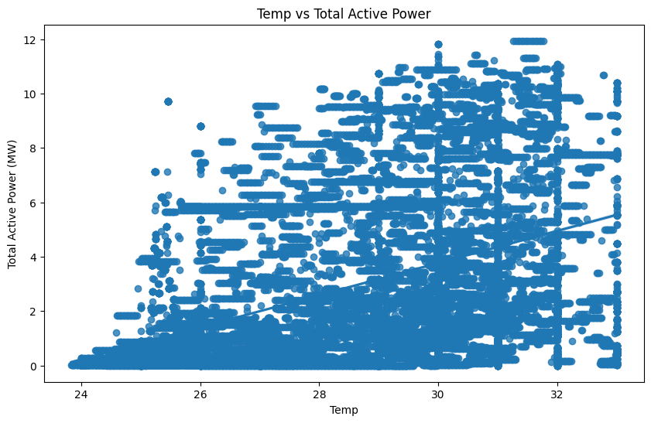

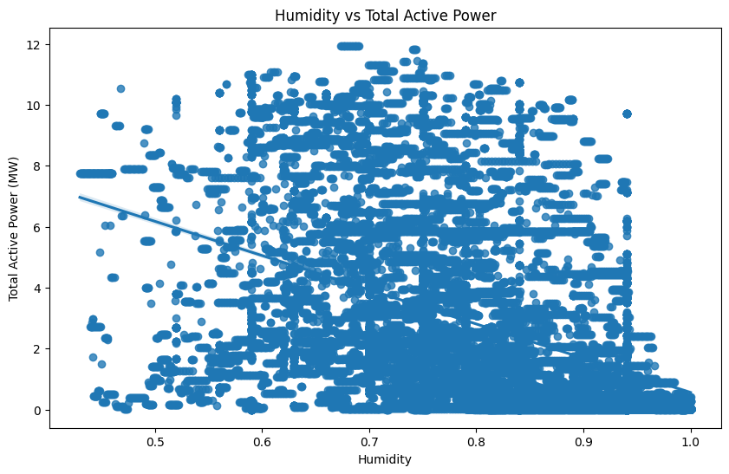

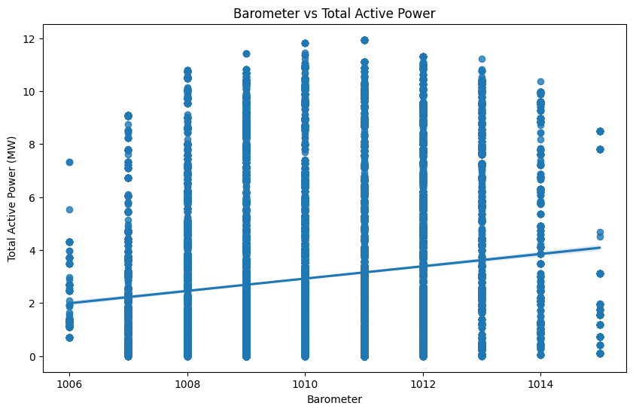

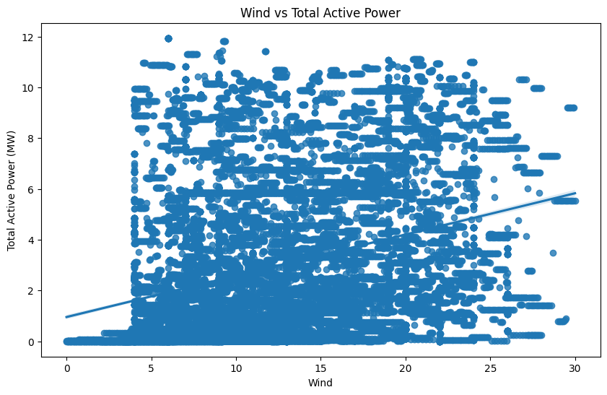

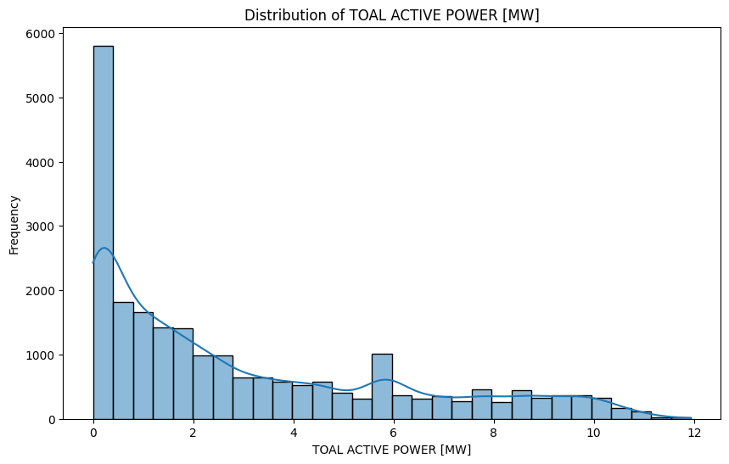

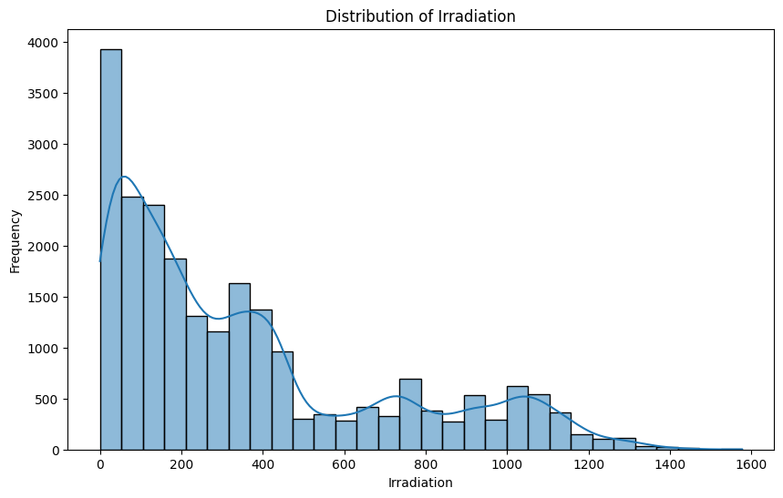

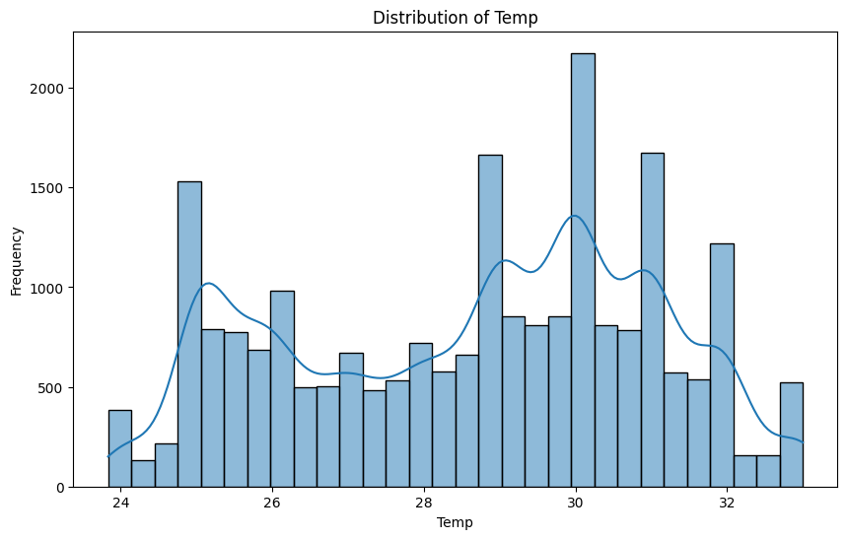

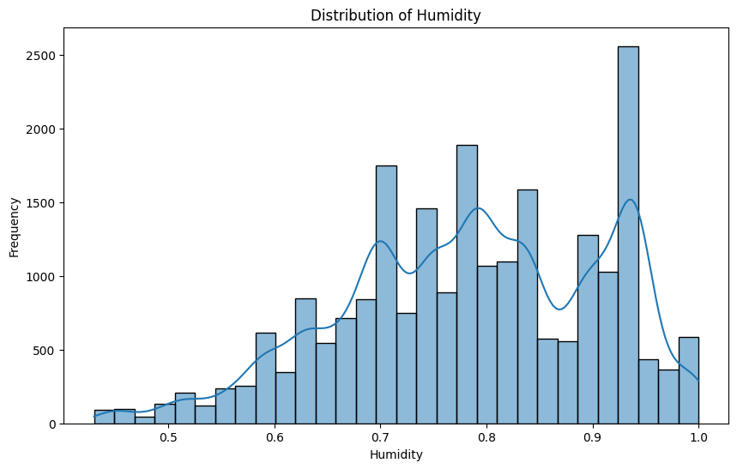

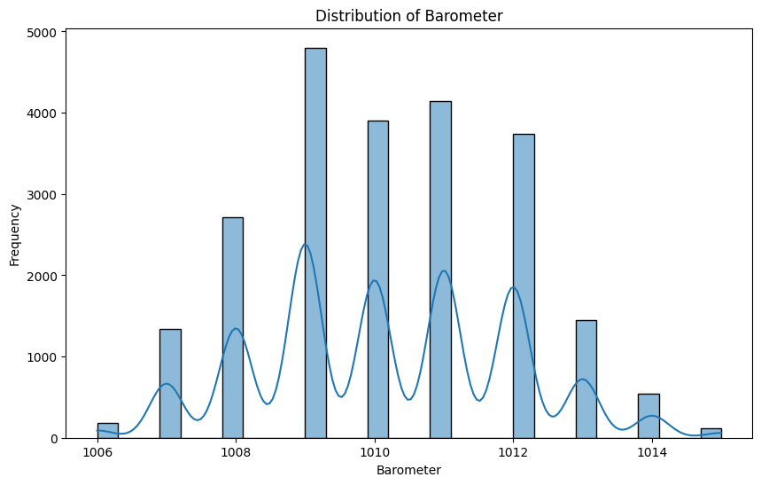

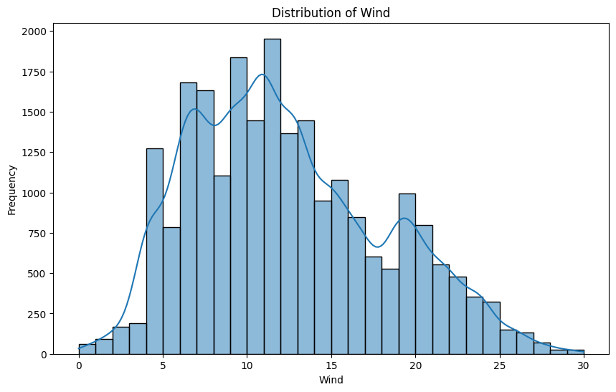

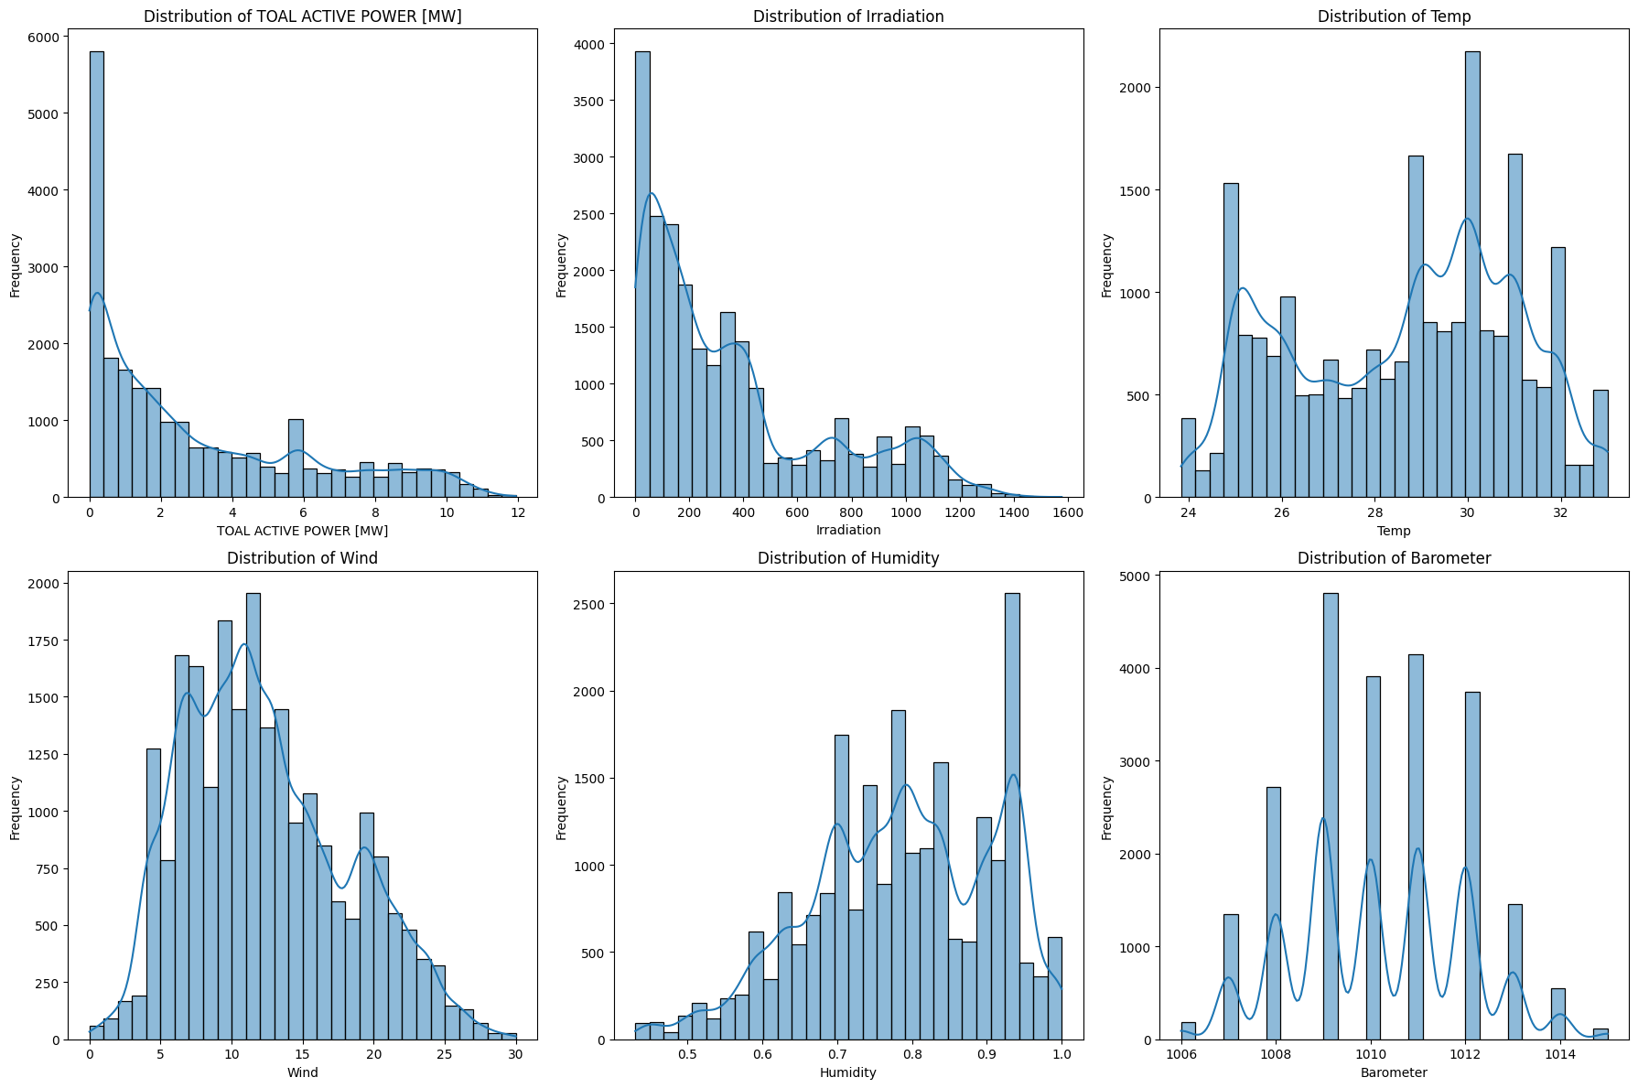

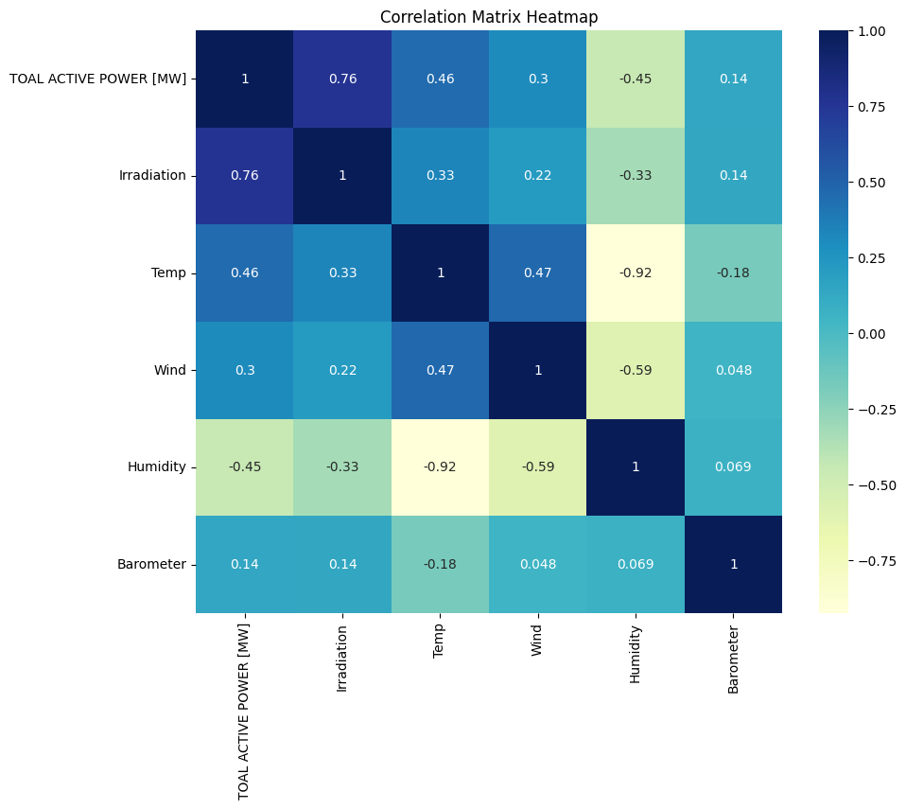

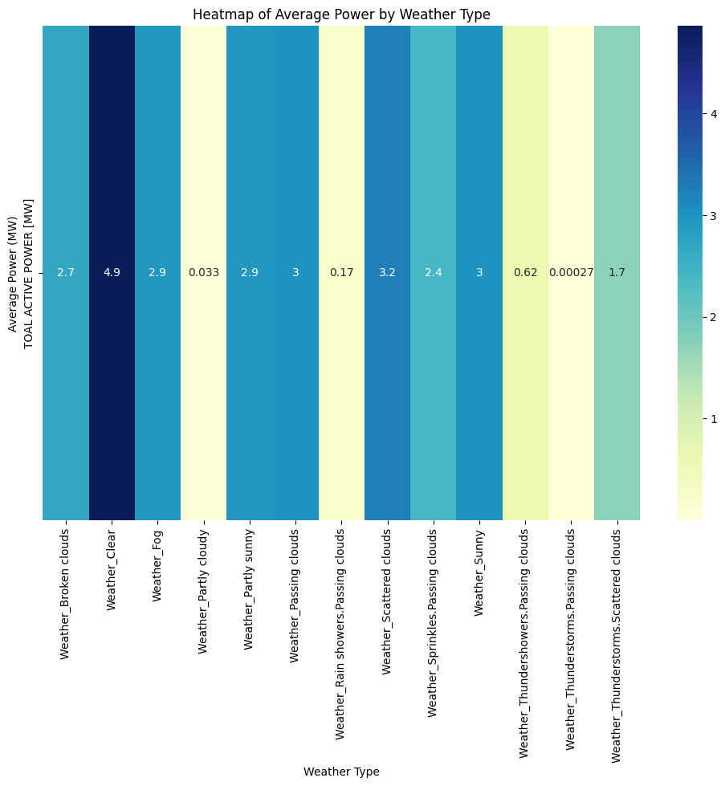

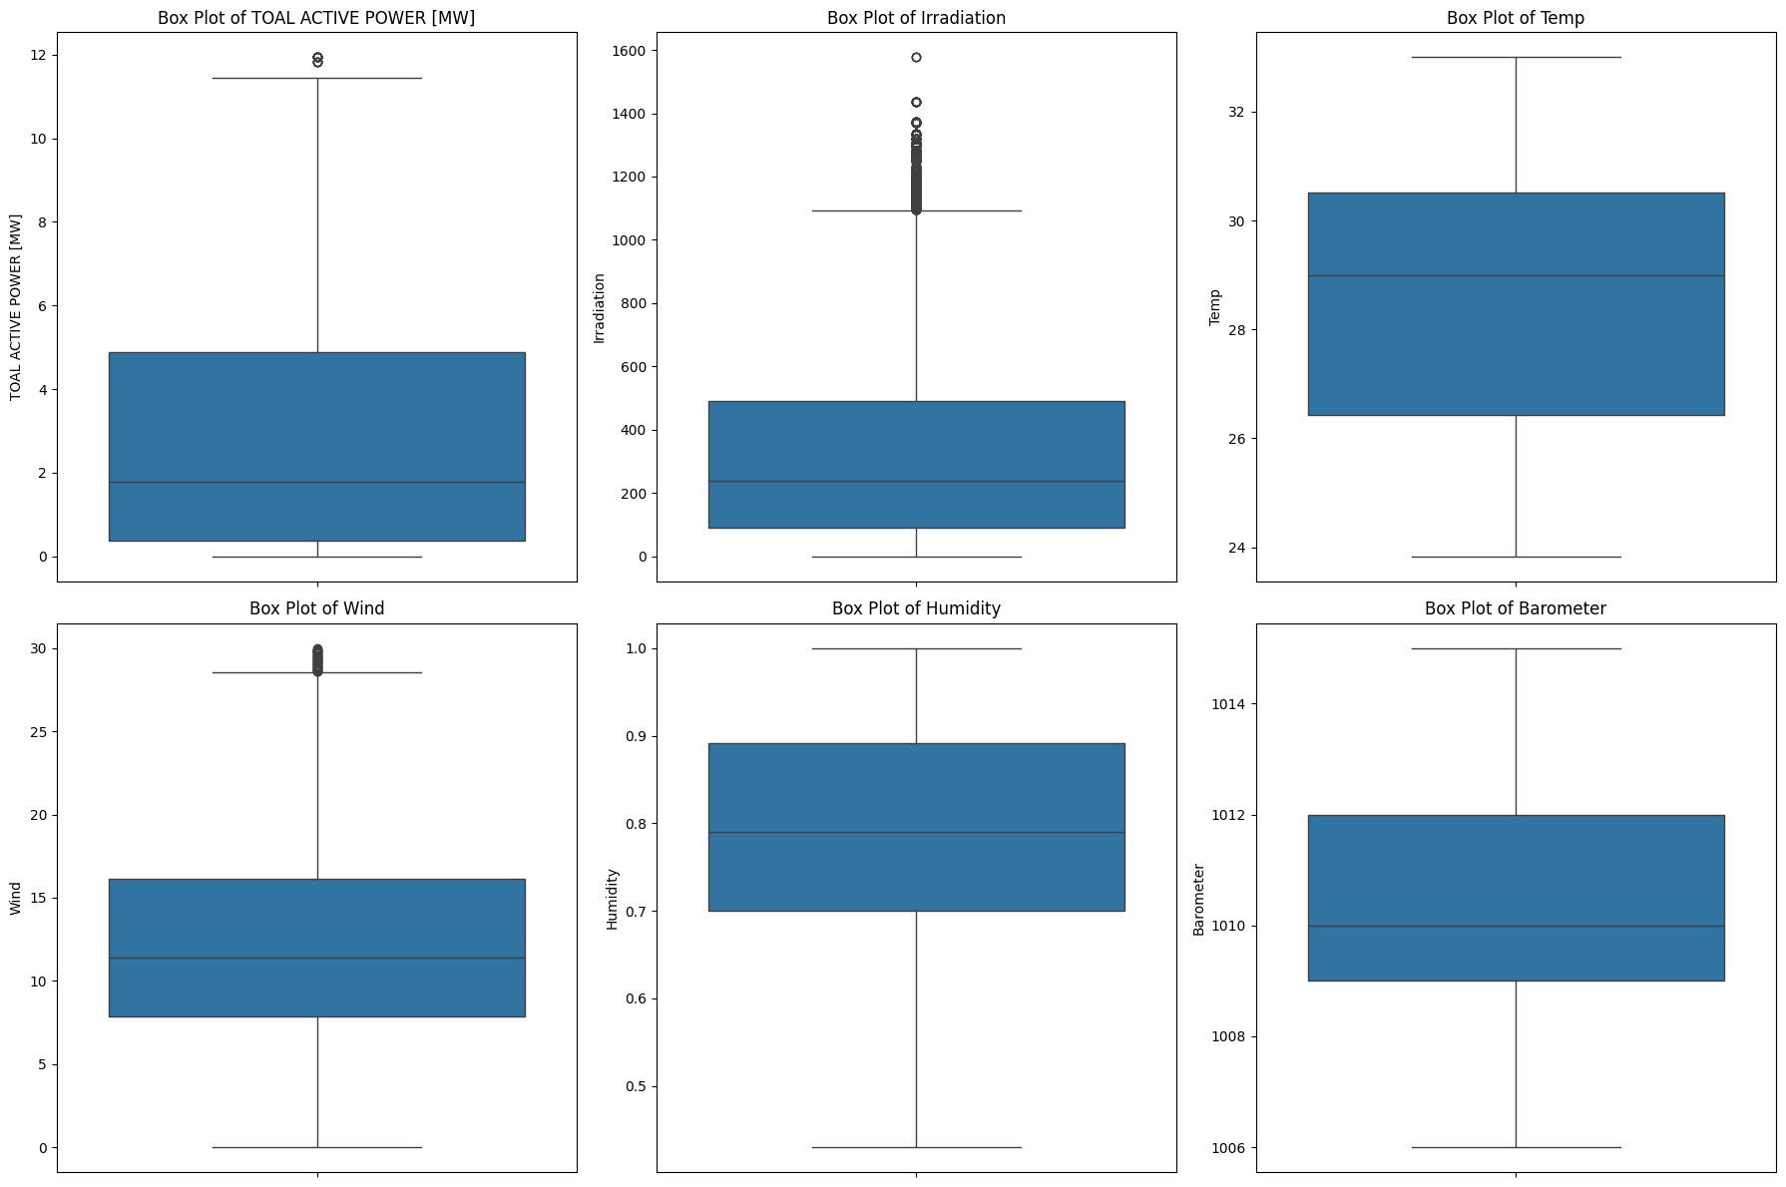

Humidity_lag_2 8.665880

Temp_lag_2 0.360276

Barometer 0.281137

Wind 0.118027

Temp 0.022579

Wind_lag_1 0.007276

Irradiation 0.005375

Irradiation_lag_2 0.000453

Irradiation_lag_1 0.000236

Temp_lag_1 -0.033841

Barometer_lag_1 -0.053965

Barometer_lag_2 -0.078208

Wind_lag_2 -0.095981

Humidity_lag_1 -0.288672

Humidity -7.145052

dtype: float64

